**OUTPUT SCREENSHOTS:**

**LOGIN PAGE:**

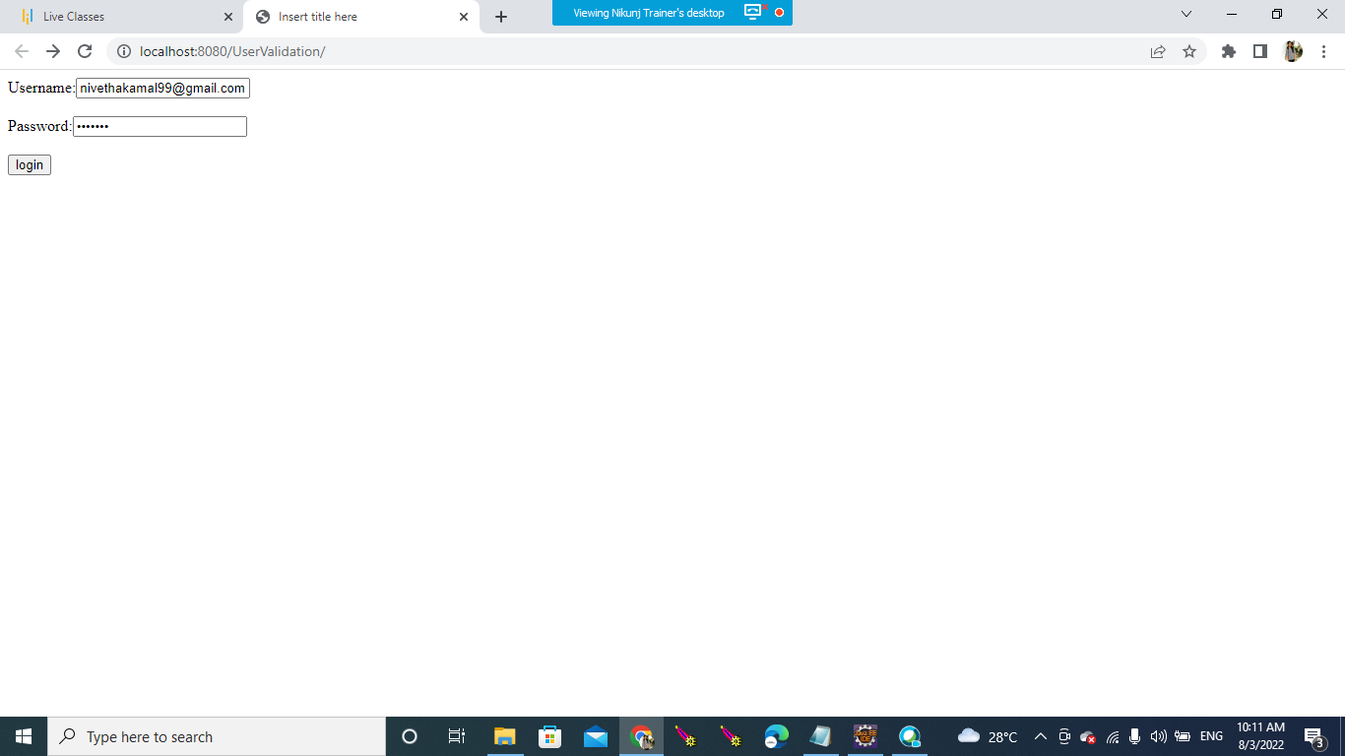

**DASHBOARD:**

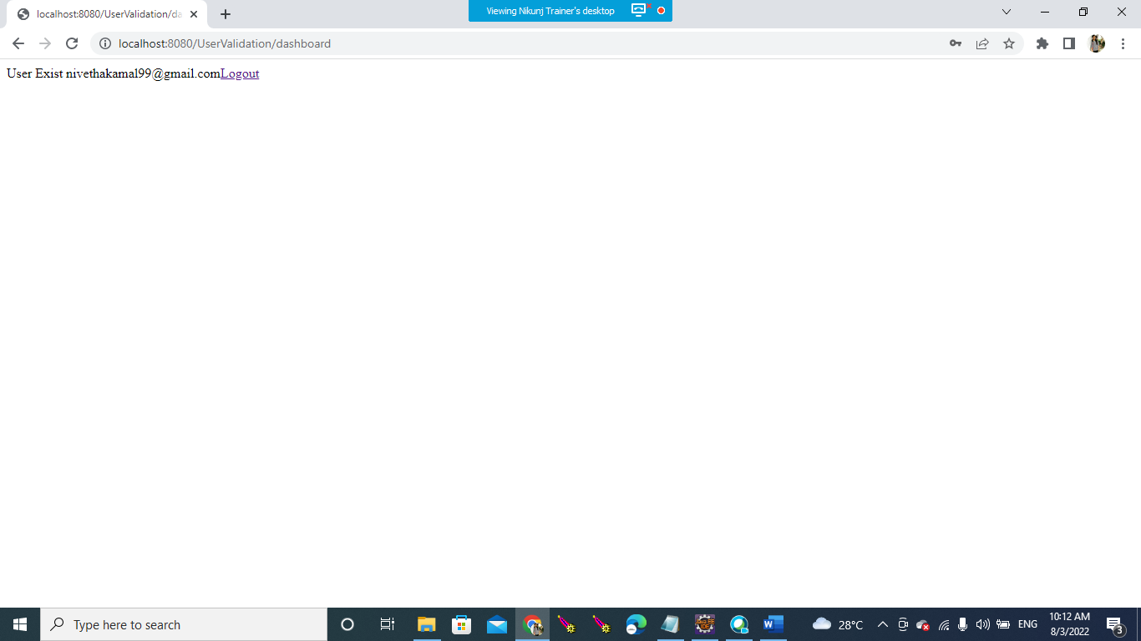

**LOGOUT:**

**INVALID USERNAME AND PASSWORD:**

